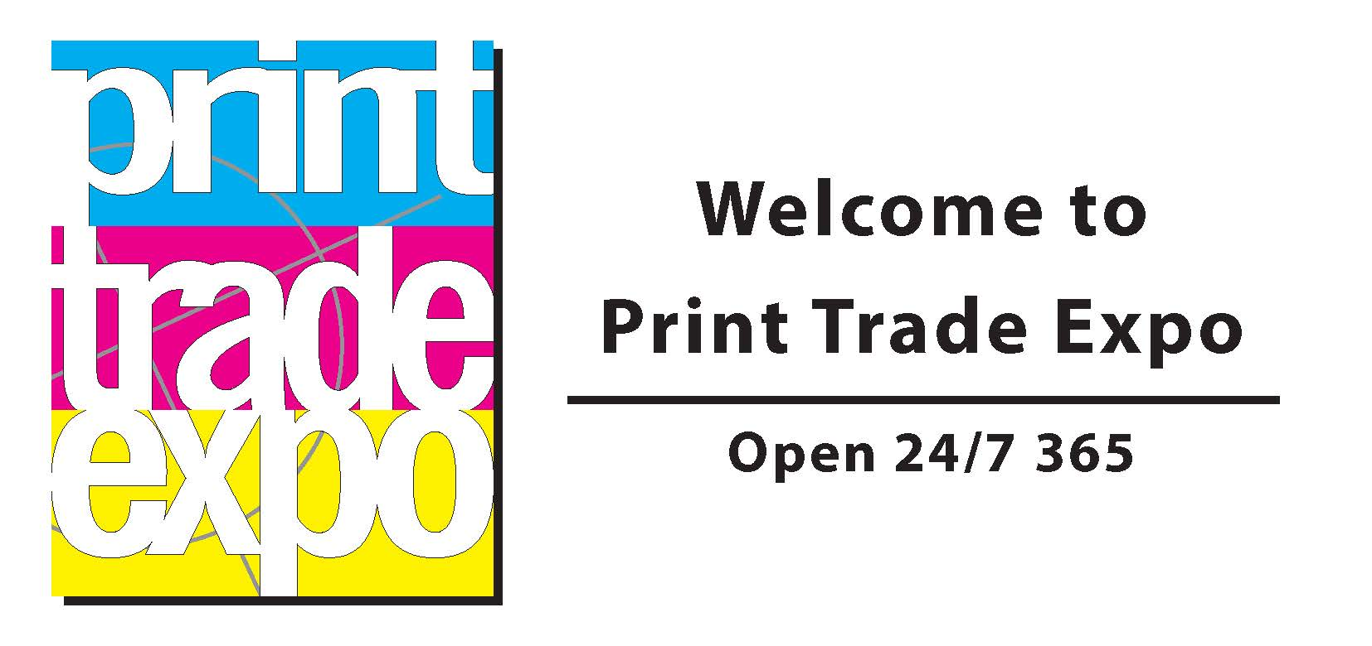

Top Trending Diary Dates

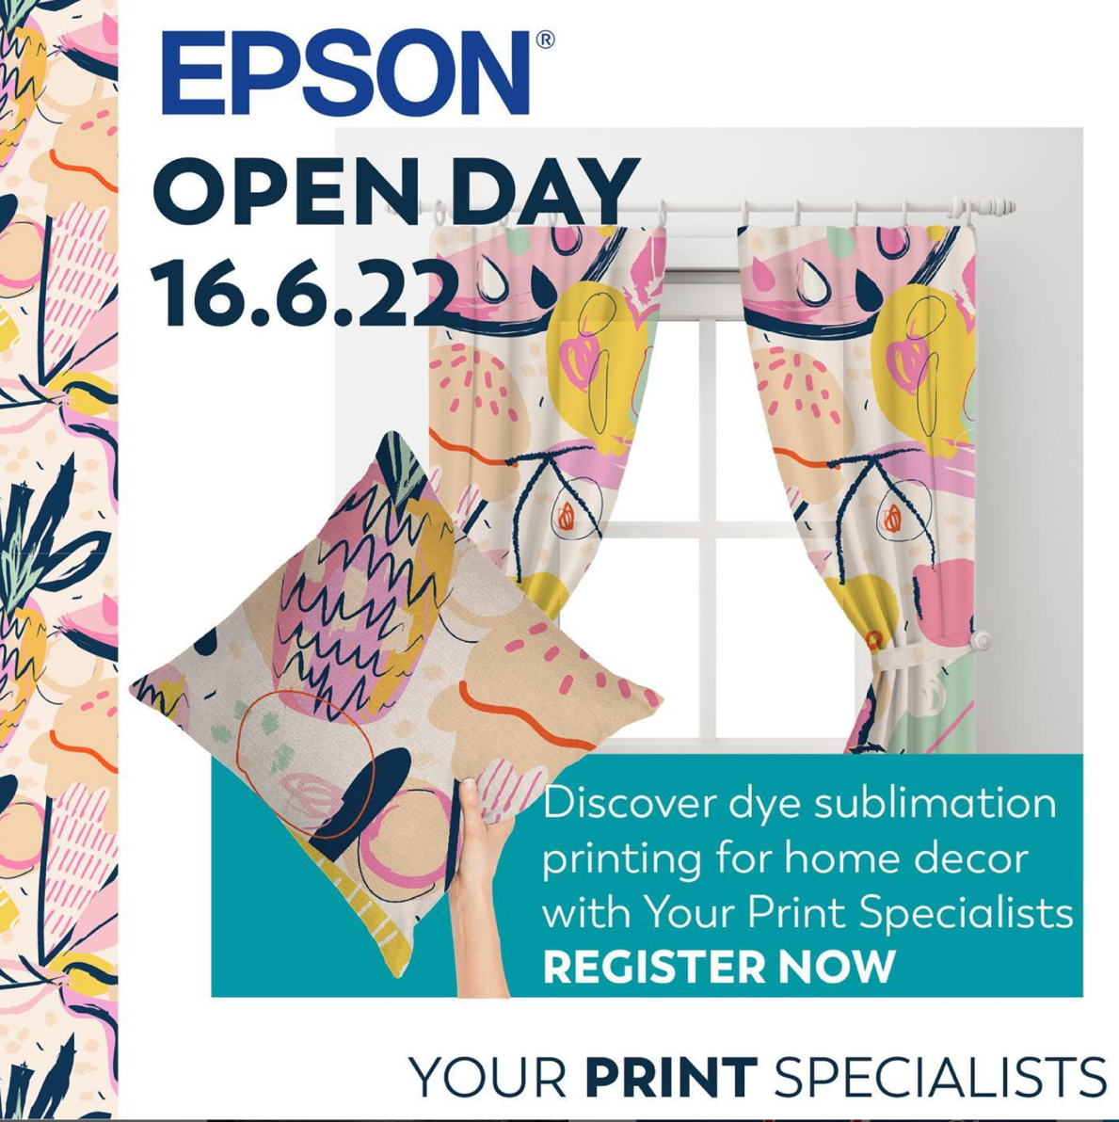

https://yourprintspecialists.co.uk/2022/05/17/epson-sc-f6300-open-day-at-yps/
Your Print Specialists are opening their doors and hosting their first open day post-pandemic on Thursday 16th June.
You are invited to YPS to see the Epson SureColor SC-F6300 dye-sublimation printer in action and the wide range of applications that are possible with Epson.

Your Print Specialists are opening their doors and hosting their first open day post-pandemic on Thursday 16th June. New and old customers alike are invited to YPS to see the Epson SureColor SC-F6300 dye-sublimation printer in action and the wide range of applications that are possible with Epson.

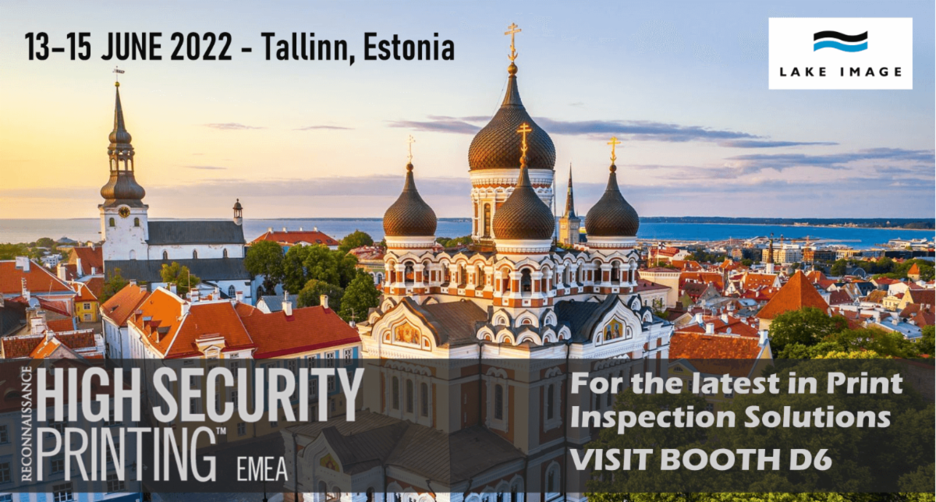

JOIN US

We're looking forward to meeting all of you at the High Security Printing EMEA event on 13th-15th June 2022 in Tallinn, Estonia

Be sure to check out our stand (D6) or book a demo - we offer the most comprehensive print inspection solutions for the Security Printing Industry.
﻿
Lake Image Systems has an excellent track record in helping security printers to ensure that their print production of security labels, tax stamps and documents are correct, accurate and traceable.

Join Perfect Colours and our key product partners at our knowledge packed 2-Hour Workshops in Sheffield, and discover the practical realities of display prints future through expert presentations and practical demonstrations.
Key speakers:
- Perfect Colours on pivoting to win business in the 'new normal' of print
- HP on print sustainability without compromise or restriction.
- Jon Hutton, Prismm on recycling and effective waste management.
Key demonstrations:
- HP will demo their R1000 flatbed, Latex 700W and PageWide XL Pro
- Summa will demonstrate an integrated cutting workflow
- Print Factory will present software that saves ink, media and time.
- Drytac will demonstrate rapid install media solutions for new applications.
Where and when:
- Perfect Colours Innovation Centre
Unit 0, Sheffield Airport Business Park, Europa Link, Sheffield S9 1XU
- Wednesday 29th & Thursday 30th of June
2 sessions daily, Morning 10:00 - 12:00 and Afternoon 14:00 to 16:00
- Refreshments will be provided throughout the day.

The Photographic Academy

The Photographic Academy is the heart of print and photography training workshops in the UK, delivering the knowledge needed to take your images to the next level. Join us and learn about the entire process to creating award-winning inkjet prints with a range of courses to suit every ability. Your prints are our passion.

Learn
Learn new skills & creative techniques to take your photography to the next level.

Grow
Leave the Academy with a newfound confidence that will help you improve your portfolio.

Be inspired
Find inspiration from leading photographers while you explore new techniques.

To find out more about the courses available and book a place visit www.thephotographicacademy.co.uk

Virtual Conference Diary

https://www.vpress.com/crown-pub-vpress/

Webinar Invitations

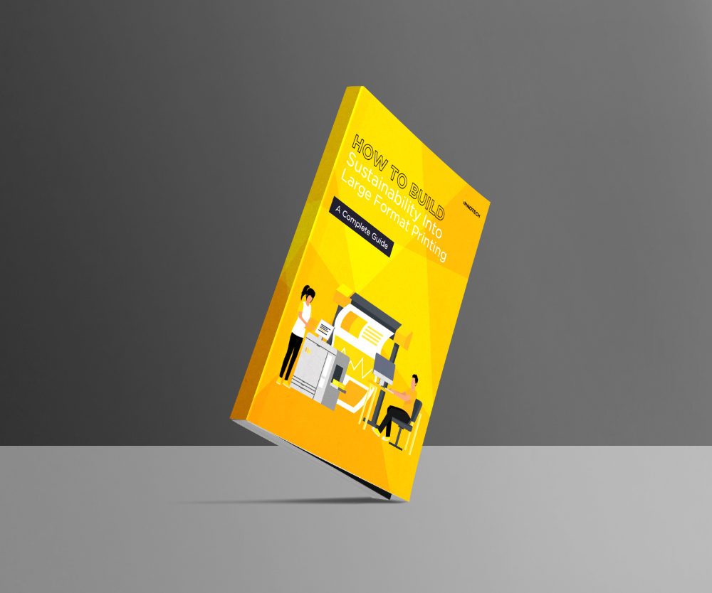

How to Build Sustainability into Large Format Printing – New Innotech eBook Available

Innotech Digital has published a comprehensive eBook covering the realities of being sustainable in the large format printing industry. The eBook is a guide to help printing companies navigate the challenges of becoming more sustainable throughout their operations.
Sustainability has become a crucial element of just about every business and industry in the world. Hardly surprising when there is an island of plastic twice the size of Texas floating in the Pacific Ocean. Global carbon emissions are at an all-time high, and over 30,000 deaths per year are caused by local air pollution in the UK alone.
Sustainability in large format printing doesn’t sound like it can make a difference to these grand problems, but everyone needs to play their part and Innotech’s guide will help print companies make key changes to their business that can make their operations more sustainable and profitable at the same time.
Printing requires materials, energy, labour, and transport all of which produces carbon. While this is inescapable, there are several ways to build sustainability into printing that can tip the balance in favour of eco-friendliness.
Building sustainability into a large format printing business is clearly worthwhile and the Innotech eBook explains how this can reduce waste disposal costs, increase efficiency, attract new customers, boost bottom line profitability and enhance reputation.
Kieran Dallow, Marketing Manager for Innotech Digital, says, “Most printers are keen to find out ways to become more green in their operations, but a lot don’t know where to start. There is an awful lot of ‘talking-the-talk’ going on in the industry and our guide is designed to show how to really do something, with actionable insights on how to help make small steps to being more green.”
Download the Innotech eBook – “How to Build Sustainability into Large Format Printing” here…

Demonstration Video Links

https://intecprinters.com/products/virtual-showroom/

https://www.designsupply.co.uk/Canon-Virtual-Showroom/

Suppliers are you planning to host a webinar, open your showroom to a virtual audience or share your YouTube video demonstrations?

Get in front of 36,000 quick print pros by contacting peter@colourfast.co.uk

